Group details:

REPORT FOR REALME WEBSITE USING HTML, CSS AND JAVASCRIPT

AS A PROJECT WORK FOR THE COURSE

INTERNET PROGRAMMING (CSE:326)

NAME: K.DANIEL Paul, P.KOUSHIKA, G.SURYA AJAY REDDY

REG NO: 12200393,12200417,12206540

ROLL NUMBER:11,12,26

SEMISTER: FIRST SEMISTER

SUBMITTED TO: JASPREET KAUR

SCHOOL OF COMPUTER SCIENCE END ENGINEERING.

LOVELY PROFESSIONAL UNIVERSITY,JALANDHAR,PUNJAB,INDIA.

Project : realme website

REALME HTML

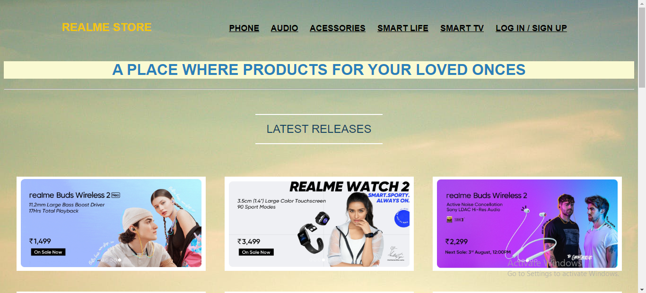

SMART PHONES PAGE

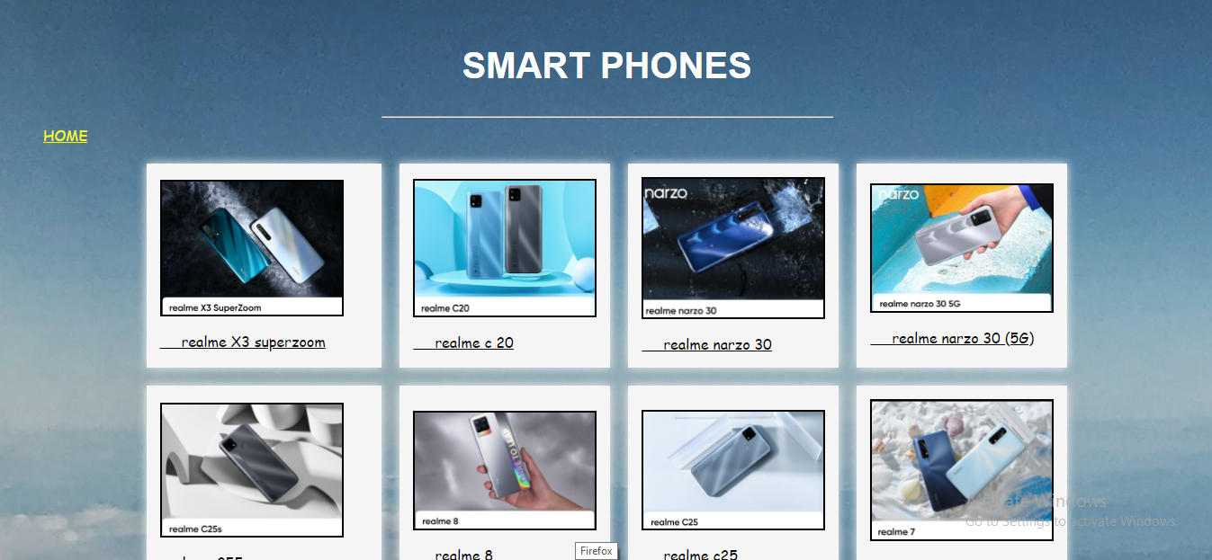

AUDIO DEVICE SECTION

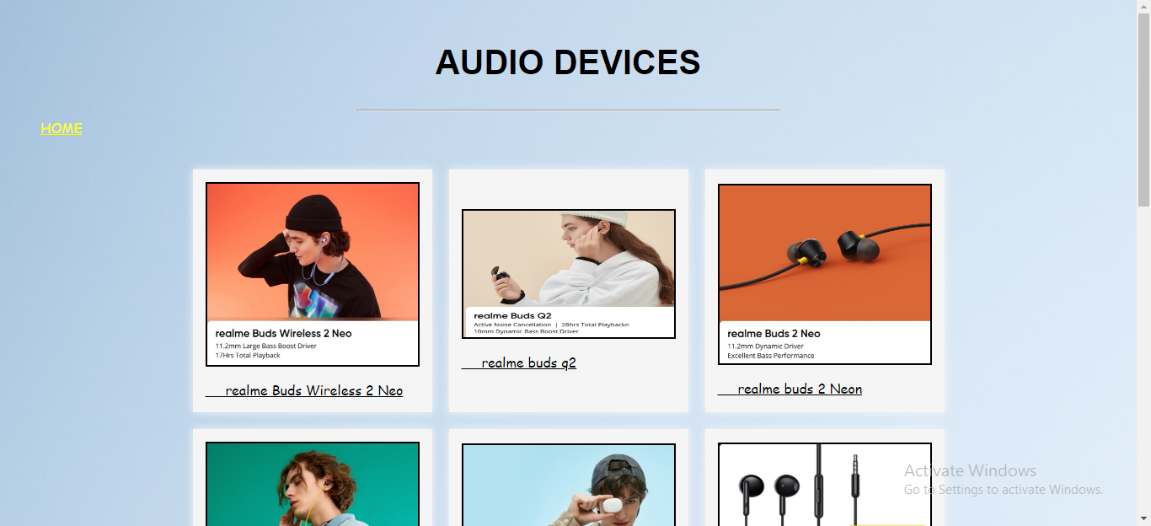

ACESSORIES DEVICES PAGE

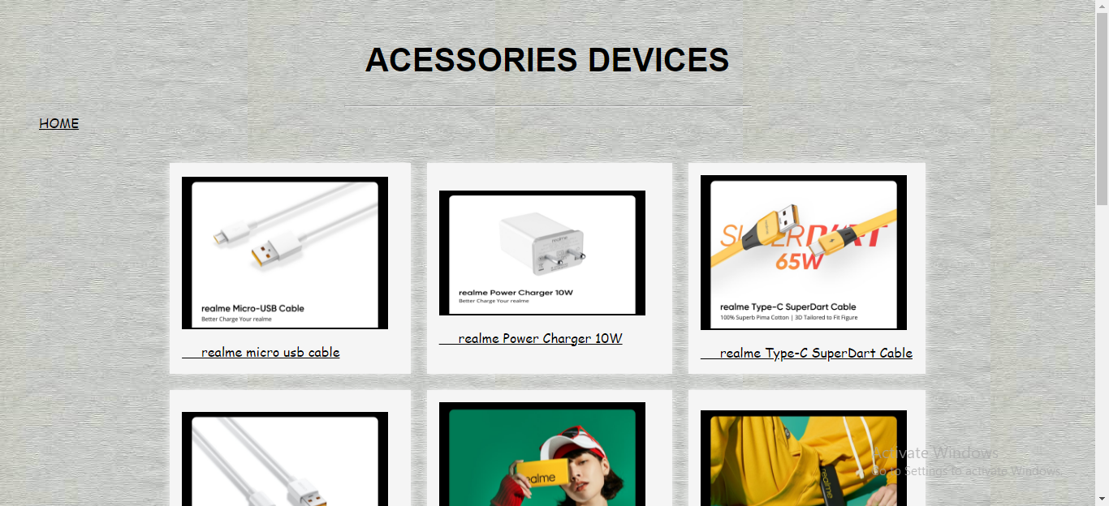

SMART LIFE SECTION PAGE

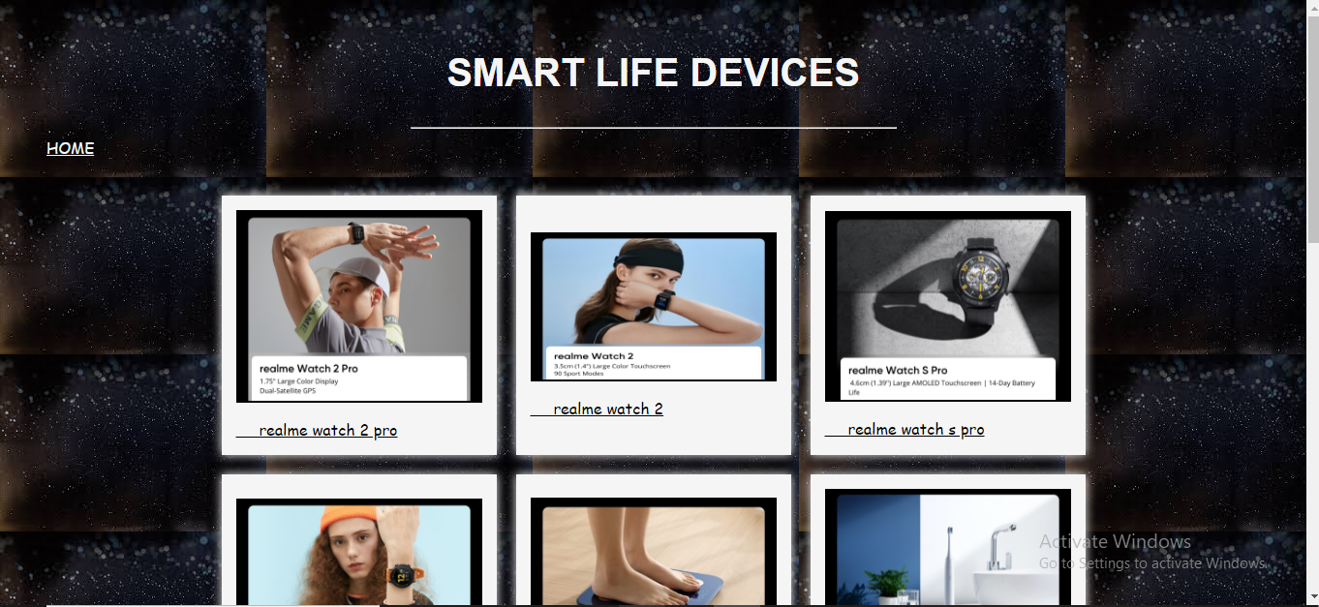

SMART TV SECTION PAGE

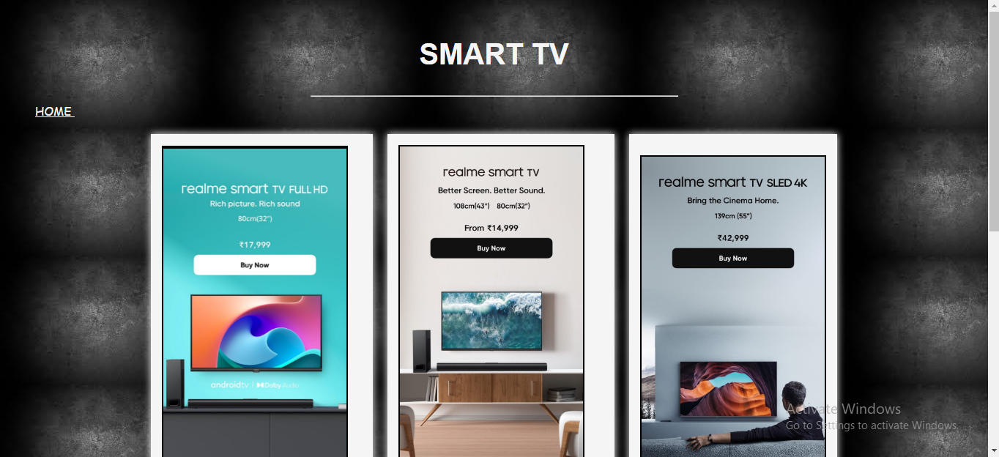

ROLLING IMAGES FEATURES

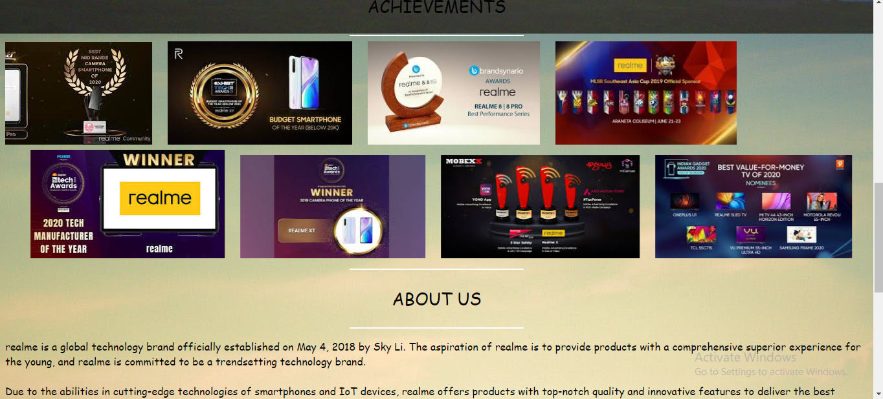

LOG IN PAGE

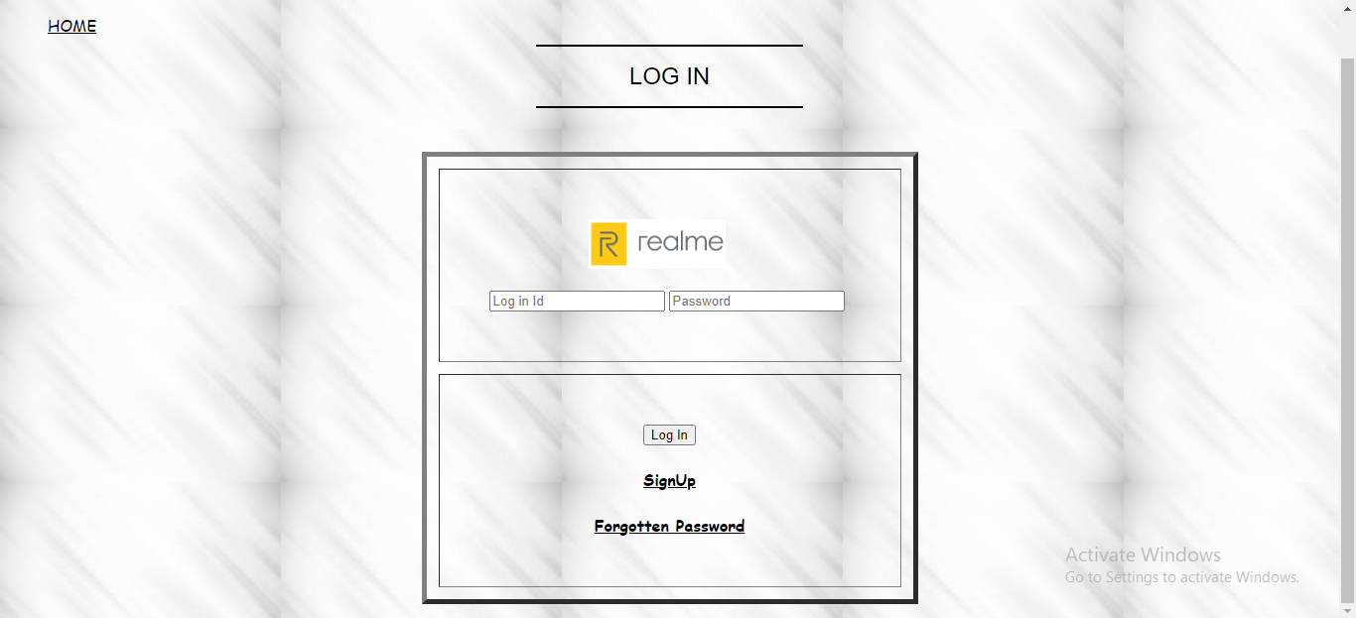

SIGN UP PAGE

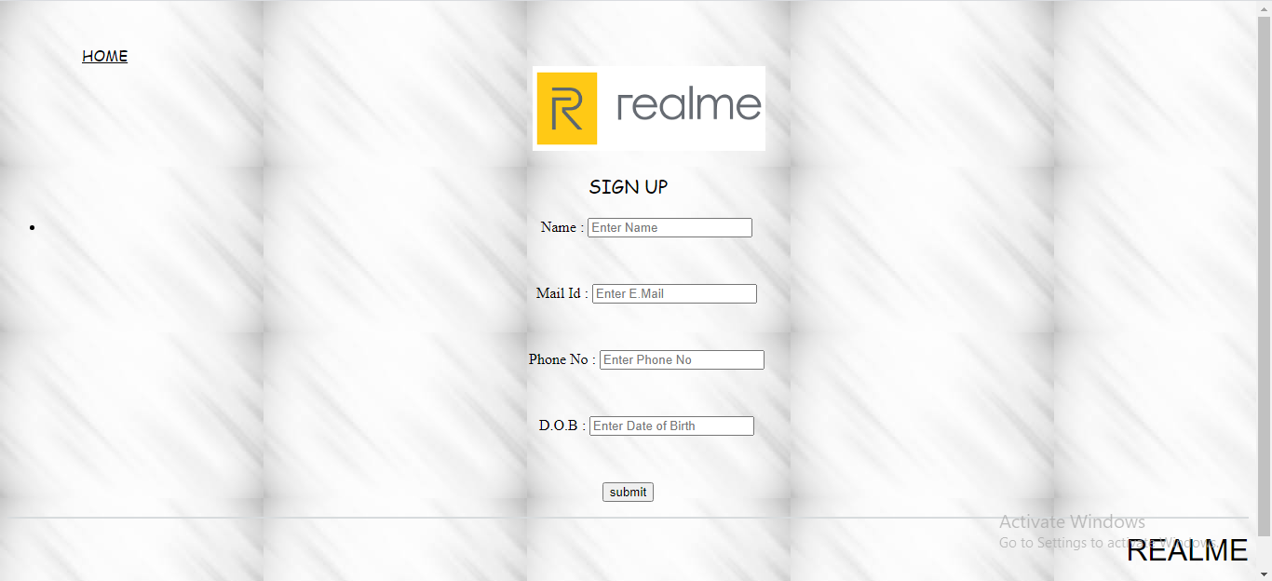

FORGOTTEN PASSWORD PAGE

Front page code:

<!DOCTYPE html>

<html lang="en">

<head>

    <meta charset="utf-8">

    <title>

    Realme website

    </title>

</head>

<body background="C:\Users\User\Desktop\realme\banner.jpeg" link="#000" alink="#017bf5" vlink="#000">

        <div class="main" id="home">

            <br />

            <h3 align="center">

                <font face="sans-serif" size="5" color="#F1C40F">REALME STORE</font>

                &nbsp;&nbsp;&nbsp;&nbsp;&nbsp;&nbsp;&nbsp;&nbsp;&nbsp;&nbsp;&nbsp;&nbsp;&nbsp;&nbsp;&nbsp;&nbsp;

                &nbsp;&nbsp;&nbsp;&nbsp;&nbsp;&nbsp;&nbsp;&nbsp;&nbsp;&nbsp;&nbsp;&nbsp;&nbsp;&nbsp;&nbsp;&nbsp;

                <font face="sans-serif" size="4">

                    <a href="phone.html" target="_blank">PHONE</a>&nbsp;&nbsp;&nbsp;&nbsp;

                    <a href="audio.html" target="_blank">AUDIO</a>&nbsp;&nbsp;&nbsp;&nbsp;

                    <a href="acess.html" target="_blank">ACESSORIES</a>&nbsp;&nbsp;&nbsp;&nbsp;

                    <a href="smartlife.html" target="_blank">SMART LIFE</a>&nbsp;&nbsp;&nbsp;&nbsp;

                    <a href="smarttv.html" target="_blank">SMART TV</a>&nbsp;&nbsp;&nbsp;&nbsp;

                    <a href="loginpage.html" target="_blank">LOG IN / SIGN UP</a>&nbsp;&nbsp;&nbsp;&nbsp;

                </font>

            </h3>

            <br/>

            <h1 align="center" style="background:bisque">

                <font face="sans-serif" color="#2980b9" size="6">

                A PLACE WHERE PRODUCTS FOR YOUR LOVED ONCES

                </font>

            </h1>

    <!-- portfolio -->

    <br>

    <!-- <hr> -->

    <br>

    <div class="portfolio">

        <hr color="#fff" width="20%">

            <p align="center"><font face="sans-serif" color="#154360" size="5.5">LATEST RELEASES</font></p>

            <hr color="#fff" width="20%">

            <br><br>

            <table align="center" cellspacing="10" cellpadding="15">

                <tr>

                    <td>

                        <img src= "C:\Users\User\Desktop\realme\realme buds air 3s.png" height="200" width="400">

                    </td>

                    <td>

                        <img src="C:\Users\User\Desktop\realme\realme-Watch-3-announced.jpg" height="200" width="400">

                    </td>

                    <td>

                        <img src="C:\Users\User\Desktop\realme\realme neckband.jpg" height="200" width="400">

                    </td>

                </tr>

                <tr>

                    <td>

                        <img src="C:\Users\User\Desktop\realme\beard trimmer.jpeg" height="200" width="400">

                    </td>

                    <td>

                        <img src="C:\Users\User\Desktop\realme\realmec30launch_16062022.webp" height="200" width="400">

                    </td>

                    <td>

                        <img src= "C:\Users\User\Desktop\realme\realme narzo.jpeg" height="200" width="400">

                    </td>

                </tr>

                <th colspan="3" rowspan="2"><a href="#">LOAD MORE</a></th>

                </tr>

            </table>

        </div>

        <br><br><br>

        <hr color="#fff" width="20%">

        <p style="color: black; font-family: cursive; text-align: center; font-size: 26px;"> ACHIEVEMENTS </p>

        <hr color="#fff" width="20%">

            <marquee behavior="scroll" direction="left">

    <img src="C:\Users\User\Desktop\realme\scrolling\WhatsApp Image 2022-12-04 at 22.27.32.jpg" alt="Swimming fish">

        &nbsp;&nbsp;&nbsp;&nbsp;

    <img src="C:\Users\User\Desktop\realme\scrolling\WhatsApp Image 2022-12-04 at 22.33.54.jpg" height="160">

        &nbsp;&nbsp;&nbsp;&nbsp;

    <img src="C:\Users\User\Desktop\realme\scrolling\WhatsApp Image 2022-12-04 at 22.29.54.jpg" height="160">

        &nbsp;&nbsp;&nbsp;&nbsp;

    <img src="C:\Users\User\Desktop\realme\scrolling\WhatsApp Image 2022-12-04 at 22.33.10.jpg" height="160">

        &nbsp;&nbsp;&nbsp;&nbsp;

</marquee>

<marquee behavior="scroll" direction="right">

    <img src="C:\Users\User\Desktop\realme\scrolling\WhatsApp Image 2022-12-04 at 22.44.22.jpg" height="160" alt="Swimming fish">

        &nbsp;&nbsp;&nbsp;&nbsp;

    <img src="C:\Users\User\Desktop\realme\scrolling\WhatsApp Image 2022-12-04 at 22.27.30.jpg" height="160">

        &nbsp;&nbsp;&nbsp;&nbsp;

    <img src="C:\Users\User\Desktop\realme\scrolling\WhatsApp Image 2022-12-04 at 22.48.09.jpg" height="160">

        &nbsp;&nbsp;&nbsp;&nbsp;

    <img src="C:\Users\User\Desktop\realme\scrolling\WhatsApp Image 2022-12-04 at 22.56.03.jpg" height="160">

        &nbsp;&nbsp;&nbsp;&nbsp;

</marquee>

<hr color="#fff" width="20%">

<p style="color: black; font-family: cursive; text-align: center; font-size: 26px;"> ABOUT US </p>

<hr color="#fff" width="20%">

    <p style="color: black; font-family: cursive;"> realme is a global technology brand officially established on May 4, 2018 by Sky Li. The aspiration of realme is to provide products with a comprehensive superior experience for the young, and realme is committed to be a trendsetting technology brand.<br><br>

Due to the abilities in cutting-edge technologies of smartphones and IoT devices, realme offers products with top-notch quality and innovative features to deliver the best digital experiences to its users and fans.<br><br>

According to data from Counterpoint Research on global smartphone shipments in Q1 of 2020, realme ranks 7th with year-over-year growth rate of 157%, marking the highest growth in the world. As the world's fastest-growing smartphone brand, realme stands firmly among the mainstream smartphone brands. <br><br>

In addition, at the beginning of 2020, realme announced its dual-driven strategy of “Smartphone + AIoT”. In June of 2020, its smartphone users globally reached 35 million and its sales volume of AIoT audio products broke the record of 1 million.

</p>

<hr color="black ">

        <p style="color: black; font-family: cursive; text-align: right;"><img src="C:\Users\User\Desktop\realme\instagram-icon_1057-2227.webp" height="30" width="30"> - <a href="https://instagram.com/realmeindia?igshid=YzdkMWQ2MWU=/"> INSTAGRAM (REALME) </a></p>

        <p style="color: black; font-family: cursive; text-align: left;"><img src="C:\Users\User\Desktop\realme\facebook.webp" height="30" width="30"> - <a href="https://www.facebook.com/realmeIndia/"> FACEBOOK (REALME) </a></p>

        <p style="color: black; font-family: cursive; text-align: center;"><img src="C:\Users\User\Desktop\realme\twitter.png" height="30" width="30"> - <a href="https://twitter.com/realmeIndia?ref_src=twsrc%5Egoogle%7Ctwcamp%5Eserp%7Ctwgr%5Eauthor"> TWITTER (REALME) </a></p>

        <hr color="black ">

        <p align="left">

            <font face="sans-serif" size="4" color="#17202A"></font>

            <a href="feedback.html" target="_blank" style="text-align: right;">FEEDBACK</a>

        </p>

        <p align="right">

                <font face="sans-serif" size="6" color="white">REALME</font></a>

        </p>

        <p align="right">

            <font face="sans-serif" size="4" color="white">

                Contact Us: service.ph@realme.com<br>

                Contact No: 1800 102 2777

            </font>

        </p>

        <p style="text-align: left;"> © 2021 realme. All Rights Reserved. - Privacy Policy - Warranty Terms - User Agreement</p>

</body>

</html>

Sub page code:

(phone)

<!DOCTYPE html>

<html>

<head>

    <meta charset="utf-8">

    <title> PHONE </title>

</head>

<body background="C:\Users\User\Desktop\realme\Phonesw.jpg">

<header>

    <h2 style="color: white; font-family: sans-serif; text-align: center; font-size: 40px;"> <br> SMART PHONES </h2>

    <hr width="500">

</header>

<div class="main" id="home">

    &nbsp;&nbsp;&nbsp;&nbsp;

    &nbsp;&nbsp;&nbsp;&nbsp;

    <a href="realme.html" style="font-family: cursive; color: yellow; text-align: right;"> HOME </a>

    <table align="center" cellspacing="20" cellpadding="15">

        <tr style="background: whitesmoke;">

            <td style="box-shadow: 0 0 10px whitesmoke;">

                <img src="C:\Users\User\Desktop\realme\phone 1.jpg" width="200" border="2" >

                <p style="font-family: cursive;"> <a href=https://buy.realme.com/in/goods/582 target="_blank" style="color: black;"> &nbsp;&nbsp;&nbsp;&nbsp; realme c33 </a> </p>

            </td>

            <td style="box-shadow: 0 0 10px whitesmoke;">

                <img src="C:\Users\User\Desktop\realme\phone 2.webp" width="200" height="150" border="2">

                <p style="font-family: cursive;"> <a href="https://www.realme.com/in/realme-9-pro" target="_blank" style="color: black;">

                &nbsp;&nbsp;&nbsp;&nbsp; realme 9 pro </a> </p>

            </td>

            <td style="box-shadow: 0 0 10px whitesmoke;">

                <img src="C:\Users\User\Desktop\realme\phone 3.jpg" width="200" border="2">

                <p style="font-family: cursive;"> <a href="https://www.realme.com/in/realme-gt-2-pro" target="_blank" style="color: black;"> &nbsp;&nbsp;&nbsp;&nbsp; realme gt 2</a> </p>

            </td>

            <td style="box-shadow: 0 0 10px whitesmoke;">

                <img src="C:\Users\User\Desktop\realme\phone 4.jpeg" width="200" border="2">

                <p style="font-family: cursive;"> <a href="https://buy.realme.com/in/goods/390" target="_blank" style="color: black;"> &nbsp;&nbsp;&nbsp;&nbsp; realme 8i (5G)</a> </p>

            </td>

        </tr>

        <tr style="background: whitesmoke;">

            <td style="box-shadow: 0 0 10px whitesmoke;">

                <img src="C:\Users\User\Desktop\realme\phone 5.png" width="200" border="2">

                <p style="font-family: cursive;"> <a href="https://www.realme.com/in/realme-x7-pro" target="_blank" style="color: black;">realme x7</a> </p>

            </td>

            <td style="box-shadow: 0 0 10px whitesmoke;">

                <img src="C:\Users\User\Desktop\realme\phone 6.jpg" width="200" border="2">

                <p style="font-family: cursive;"> <a href="https://www.realme.com/in/realme-c35" target="_blank" style="color: black;"> &nbsp;&nbsp;&nbsp;&nbsp; realme c35</a> </p>

            </td>

            <td style="box-shadow: 0 0 10px whitesmoke;">

                <img src="C:\Users\User\Desktop\realme\phone 7.jpg" width="200" border="2">

                <p style="font-family: cursive;"> <a href="https://www.realme.com/in/realme-xt" target="_blank" style="color: black;">&nbsp;&nbsp;&nbsp;&nbsp; realme xt</a> </p>

            </td>

            <td style="box-shadow: 0 0 10px whitesmoke;">

                <img src="C:\Users\User\Desktop\realme\phone 8.jpg" width="200" border="2">

                <p style="font-family: cursive;"> <a href="https://www.realme.com/in/realme-7" target="_blank" style="color: black;"> &nbsp;&nbsp;&nbsp;&nbsp; realme 7</a> </p>

            </td>

        </tr>

        <tr style="background: whitesmoke;">

            <td style="box-shadow: 0 0 10px whitesmoke;">

                <img src="C:\Users\User\Desktop\realme\phone 9.png" width="200" border="2">

                <p style="font-family: cursive;"> <a href="https://www.realme.com/in/realme-c15" target="_blank" style="color: black;">

                &nbsp;&nbsp;&nbsp;&nbsp; realme c15 (Special Edition)</a> </p>

            </td>

            <td style="box-shadow: 0 0 10px whitesmoke;">

                <img src="C:\Users\User\Desktop\realme\phone 10.jpeg" width="200" border="2">

                <p style="font-family: cursive;"> <a href="https://www.realme.com/in/realme-c2" target="_blank" style="color: black;">

                &nbsp;&nbsp;&nbsp;&nbsp; realme c2 (5G)</a> </p>

            </td>

            <td style="box-shadow: 0 0 10px whitesmoke;">

                <img src="C:\Users\User\Desktop\realme\phone 11.jpeg" width="200" border="2">

                <p style="font-family: cursive;"> <a href="https://www.realme.com/in/realme-6" target="_blank" style="color: black;">

                &nbsp;&nbsp;&nbsp;&nbsp; realme 6</a> </p>

            </td>

            <td style="box-shadow: 0 0 10px whitesmoke;">

                <img src="C:\Users\User\Desktop\realme\phone 12.webp" width="200" border="2">

                <p style="font-family: cursive;"> <a href="https://www.realme.com/in/realme-9" target="_blank" style="color: black;">

                &nbsp;&nbsp;&nbsp;&nbsp;realme 9</a> </p>

            </td>

        </tr>

    </table>

    <br><br><br><br><br><br><br>

    <br><br><br><br><br><br><br>

    <br><br><br><br><br><br><br>

        <hr color="#D7DBDD ">

        <p align="right">

                <font face="sans-serif" size="6" color="#F1C40F">REALME</font></a>

        </p>

        <p align="right">

            <font face="sans-serif" size="4" color="#17202A">

                Contact Us: 1800 102 2777

            </font>

        </p>

</div>

</body>

</html>

Sub page code:

(audio)

<!DOCTYPE html>

<html>

<head>

    <meta charset="utf-8">

    <title> AUDIO </title>

</head>

<body background="C:\Users\User\Desktop\realme\sky-clouds-sky-blue-blue-background-wallpaper-1.jpg">

<header>

    <h2 style="color: white; font-family: sans-serif; text-align: center; font-size: 40px; color: black;"> <br> AUDIO DEVICES </h2>

    <hr width="500">

</header>

<div class="main" id="home">

    &nbsp;&nbsp;&nbsp;&nbsp;

    &nbsp;&nbsp;&nbsp;&nbsp;

    <a href="realme.html" style="font-family: cursive; color: yellow; text-align: right;"> HOME </a>

    <table align="center" cellspacing="20" cellpadding="15">

        <tr style="background: whitesmoke;">

            <td style="box-shadow: 0 0 10px whitesmoke;">

                <img src="C:\Users\User\Desktop\realme\audio 1.jpg" width="250" border="2" >

                <p style="font-family: cursive;"> <a href="https://www.realme.com/in/realme-buds-wireless-2" target="_blank" style="color: black;"> &nbsp;&nbsp;&nbsp;&nbsp; realme Buds Wireless 2 Neo </a> </p>

            </td>

            <td style="box-shadow: 0 0 10px whitesmoke;">

                <img src="C:\Users\User\Desktop\realme\audio 2.jpeg" width="250" height="150" border="2">

                <p style="font-family: cursive;"> <a href="https://www.realme.com/in/realme-buds-q2" target="_blank" style="color: black;">

                &nbsp;&nbsp;&nbsp;&nbsp; realme buds q2</a> </p>

            </td>

            <td style="box-shadow: 0 0 10px whitesmoke;">

                <img src="C:\Users\User\Desktop\realme\audio 3.jpg" width="250" border="2">

                <p style="font-family: cursive;"> <a href="https://buy.realme.com/in/goods/379" target="_blank" style="color: black;"> &nbsp;&nbsp;&nbsp;&nbsp; realme buds 2 Neon</a> </p>

            </td>

        </tr>

            <br>

        <tr style="background: whitesmoke;">

            <td style="box-shadow: 0 0 10px whitesmoke;">

                <img src="C:\Users\User\Desktop\realme\audio 4.jpeg" width="250" border="2">

                <p style="font-family: cursive;"> <a href="https://www.realme.com/in/realme-buds-wireless-pro" target="_blank" style="color: black;"> &nbsp;&nbsp;&nbsp;&nbsp; realme buds wireless pro</a> </p>

            </td>

            <td style="box-shadow: 0 0 10px whitesmoke;">

                <img src="C:\Users\User\Desktop\realme\audio 5.jpg" width="250" border="2">

                <p style="font-family: cursive;"> <a href="https://www.realme.com/in/realme-buds-air-3" target="_blank" style="color: black;">realme buds air 3</a> </p>

            </td>

            <td style="box-shadow: 0 0 10px whitesmoke;">

                <img src="C:\Users\User\Desktop\realme\audio 6.jpeg" width="250" border="2">

                <p style="font-family: cursive;"> <a href="https://buy.realme.com/in/goods/234" target="_blank" style="color: black;"> &nbsp;&nbsp;&nbsp;&nbsp; realme buds classic </a> </p>

            </td>

        </tr>

            <br>

        <tr style="background: whitesmoke;">

            <td style="box-shadow: 0 0 10px whitesmoke;">

                <img src="C:\Users\User\Desktop\realme\audio 7.webp" width="250" border="2">

                <p style="font-family: cursive;"> <a href="https://www.realme.com/in/realme-buds-air-neo" target="_blank" style="color: black;">&nbsp;&nbsp;&nbsp;&nbsp; realme buds air Neno </a> </p>

            </td>

        </tr>

    </table>

    <br><br><br><br><br><br><br>

    <br><br><br><br><br><br><br>

    <br><br><br><br><br><br><br>

        <hr color="#D7DBDD ">

        <p align="right">

                <font face="sans-serif" size="6" color="#F1C40F">REALME</font></a>

        </p>

        <p align="right">

            <font face="sans-serif" size="4" color="#17202A">

                Contact Us: 1800 102 2777

            </font>

        </p>

</div>

</body>

</html>

Sub code:

(accessories)

<!DOCTYPE html>

<html>

<head>

    <meta charset="utf-8">

    <title> ACESSORIES  </title>

</head>

<body background="C:\Users\User\Desktop\realme\WhatsApp Image 2022-12-07 at 11.20.39.jpg">

<header>

    <h2 style="color: white; font-family: sans-serif; text-align: center; font-size: 40px; color: yellow;"> <br> ACESSORIES  DEVICES </h2>

    <hr width="500">

</header>

<div class="main" id="home">

    &nbsp;&nbsp;&nbsp;&nbsp;

    &nbsp;&nbsp;&nbsp;&nbsp;

    <a href="realme.html" style="font-family: cursive; color: black; text-align: right;"> HOME </a>

    <table align="center" cellspacing="20" cellpadding="15">

        <tr style="background: whitesmoke;">

            <td style="box-shadow: 0 0 10px whitesmoke;">

                <img src="C:\Users\User\Desktop\realme\acess1.jpeg" width="250" border="2" >

                <p style="font-family: cursive;"> <a href="https://buy.realme.com/in/goods/126" target="_blank" style="color: black;"> &nbsp;&nbsp;&nbsp;&nbsp; realme micro usb cable </a> </p>

            </td>

            <td style="box-shadow: 0 0 10px whitesmoke;">

                <img src="C:\Users\User\Desktop\realme\acess2.jpeg" width="250" height="150" border="2">

                <p style="font-family: cursive;"> <a href="https://buy.realme.com/id/goods/275" target="_blank" style="color: black;">

                &nbsp;&nbsp;&nbsp;&nbsp; realme Power Charger 10W</a> </p>

            </td>

            <td style="box-shadow: 0 0 10px whitesmoke;">

                <img src="C:\Users\User\Desktop\realme\acess3.jpeg" width="250" border="2">

                <p style="font-family: cursive;"> <a href="https://buy.realme.com/in/goods/261" target="_blank" style="color: black;"> &nbsp;&nbsp;&nbsp;&nbsp; realme Type-C SuperDart Cable</a> </p>

            </td>

        </tr>

            <br>

        <tr style="background: whitesmoke;">

            <td style="box-shadow: 0 0 10px whitesmoke;">

                <img src="C:\Users\User\Desktop\realme\acess4.jpeg" width="250" border="2">

                <p style="font-family: cursive;"> <a href="https://buy.realme.com/in/goods/124" target="_blank" style="color: black;"> &nbsp;&nbsp;&nbsp;&nbsp; realme Type-C VOOC Cable</a> </p>

            </td>

            <td style="box-shadow: 0 0 10px whitesmoke;">

                <img src="C:\Users\User\Desktop\realme\acess5.jpeg" width="250" border="2">

                <p style="font-family: cursive;"> <a href="https://www.realme.com/my/realme-30w-dart-charge-power-bank" target="_blank" style="color: black;">realme 30W Dart Charge 10000mAh <br> Power Bank</a> </p>

            </td>

            <td style="box-shadow: 0 0 10px whitesmoke;">

                <img src="C:\Users\User\Desktop\realme\acess6.jpeg" width="250" border="2">

                <p style="font-family: cursive;"> <a href="https://www.realme.com/ph/realme-power-bank-2" target="_blank" style="color: black;"> &nbsp;&nbsp;&nbsp;&nbsp; realme 10000mAh Power Bank 2 </a> </p>

            </td>

        </tr>

            <br>

        <tr style="background: whitesmoke;">

            <td style="box-shadow: 0 0 10px whitesmoke;">

                <img src="C:\Users\User\Desktop\realme\acess7.jpeg" width="250" border="2">

                <p style="font-family: cursive;"> <a href="https://www.realme.com/ph/realme-power-bank-2i" target="_blank" style="color: black;">&nbsp;&nbsp;&nbsp;&nbsp; realme 10000mAh Power Bank 2i </a> </p>

            </td>

        </tr>

    </table>

    <br><br><br><br><br><br><br>

    <br><br><br><br><br><br><br>

    <br><br><br><br><br><br><br>

        <hr color="#D7DBDD ">

        <p align="right">

                <font face="sans-serif" size="6" color="#F1C40F">REALME</font></a>

        </p>

        <p align="right">

            <font face="sans-serif" size="4" color="#FFFFFF">

                Contact Us: 1800 102 2777

            </font>

        </p>

</div>

</body>

</html>

Sub code:

(smart life)

<!DOCTYPE html>

<html>

<head>

    <meta charset="utf-8">

    <title> SmartLife  </title>

</head>

<body background="C:\Users\User\Desktop\realme\istockphoto-614518922-170667a.jpg">

<header>

    <h2 style="color: white; font-family: sans-serif; text-align: center; font-size: 40px; color: whitesmoke;"> <br> SMART LIFE DEVICES </h2>

    <hr width="500">

</header>

<div class="main" id="home">

    &nbsp;&nbsp;&nbsp;&nbsp;

    &nbsp;&nbsp;&nbsp;&nbsp;

    <a href="realme.html" style="font-family: cursive; color: whitesmoke; text-align: right;"> HOME </a>

    <table align="center" cellspacing="20" cellpadding="15">

        <tr style="background: whitesmoke;">

            <td style="box-shadow: 0 0 10px whitesmoke;">

                <img src="C:\Users\User\Desktop\realme\smartlife1.jpg" width="250" border="2" >

                <p style="font-family: cursive;"> <a href="https://buy.realme.com/in/goods/557" target="_blank" style="color: black;"> &nbsp;&nbsp;&nbsp;&nbsp; realme watch 3 pro </a> </p>

            </td>

            <td style="box-shadow: 0 0 10px whitesmoke;">

                <img src="C:\Users\User\Desktop\realme\smartlife2.jpeg" width="250" height="150" border="2">

                <p style="font-family: cursive;"> <a href= "https://buy.realme.com/in/goods/388"target="_blank" style="color: black;">

                &nbsp;&nbsp;&nbsp;&nbsp; realme watch 2 pro</a> </p>

            </td>

            <td style="box-shadow: 0 0 10px whitesmoke;">

                <img src="C:\Users\User\Desktop\realme\smartlife3.jpeg" width="250" border="2">

                <p style="font-family: cursive;"> <a href="https://www.realme.com/my/realme-watch-2" target="_blank" style="color: black;"> &nbsp;&nbsp;&nbsp;&nbsp; realme watch 2</a> </p>

            </td>

        </tr>

            <br>

        <tr style="background: whitesmoke;">

            <td style="box-shadow: 0 0 10px whitesmoke;">

                <img src="C:\Users\User\Desktop\realme\smartlife4.jpeg" width="250" border="2">

                <p style="font-family: cursive;"> <a href="https://www.realme.com/in/realme-watch-s-pro" target="_blank" style="color: black;"> &nbsp;&nbsp;&nbsp;&nbsp;

realme watch s</a> </p>

            </td>

            <td style="box-shadow: 0 0 10px whitesmoke;">

                <img src="C:\Users\User\Desktop\realme\smartlife5.jpeg" width="250" border="2">

                <p style="font-family: cursive;"> <a href="https://www.realme.com/in/support/kw/doc/2020722

" target="_blank" style="color: black;">realme smart scale</a> </p>

            </td>

            <td style="box-shadow: 0 0 10px whitesmoke;">

                <img src="C:\Users\User\Desktop\realme\smartlife6.jpeg" width="250" border="2">

                <p style="font-family: cursive;"> <a href="https://buy.realme.com/in/goods/239" target="_blank" style="color: black;"> &nbsp;&nbsp;&nbsp;&nbsp; realme m1 sonic <br>electric toothbrush </a> </p>

            </td>

        </tr>

            <br>

        <tr style="background: whitesmoke;">

            <td style="box-shadow: 0 0 10px whitesmoke;">

                <img src="C:\Users\User\Desktop\realme\smartlife7.jpeg" width="250" border="2">

                <p style="font-family: cursive;"> <a href="https://buy.realme.com/in/goods/334" target="_blank" style="color: black;">&nbsp;&nbsp;&nbsp;&nbsp; realme led smart bulb </a> </p>

            </td>

        </tr>

    </table>

    <br><br><br><br><br><br><br>

    <br><br><br><br><br><br><br>

    <br><br><br><br><br><br><br>

        <hr color="#D7DBDD ">

        <p align="right">

                <font face="sans-serif" size="6" color="#F1C40F">REALME</font></a>

        </p>

        <p align="right">

            <font face="sans-serif" size="4" color="white">

                Contact Us: 1800 102 2777

            </font>

        </p>

</div>

</body>

</html>

Sub code

(smarttv)

<!DOCTYPE html>

<html>

<head>

    <meta charset="utf-8">

    <title> SmartTv  </title>

</head>

<body background="C:\Users\User\Desktop\realme\black_mountains_dark_theme_wallpapers_by_mayankgorecha_debqlqh-fullview.jpg">

<header>

    <h2 style="color: white; font-family: sans-serif; text-align: center; font-size: 40px; color: whitesmoke;"> <br> SMART TV </h2>

    <hr width="500">

</header>

<div class="main" id="home">

    &nbsp;&nbsp;&nbsp;&nbsp;

    &nbsp;&nbsp;&nbsp;&nbsp;

    <a href="realme.html" style="font-family: cursive; color: whitesmoke; text-align: right;"> HOME </a>

    <table align="center" cellspacing="20" cellpadding="15">

        <tr style="background: whitesmoke;">

            <td style="box-shadow: 0 0 10px whitesmoke;">

                <img src="C:\Users\User\Desktop\realme\smarttv1.jpeg" width="250" border="2" >

                <p style="font-family: cursive;"> <a href="https://buy.realme.com/in/goods/420" target="_blank" style="color: black;"> &nbsp;&nbsp;&nbsp;&nbsp; realme smart tv full hd 80cm(32) </a> </p>

            </td>

            &nbsp;&nbsp;&nbsp;

            <td style="box-shadow: 0 0 10px whitesmoke;">

                <img src="C:\Users\User\Desktop\realme\smarttv3.jpeg" width="250" border="2">

                <p style="font-family: cursive;"> <a href="https://www.realme.com/in/realme-smart-tv-4k" target="_blank" style="color: black;"> &nbsp;&nbsp;&nbsp;&nbsp; realme smart tv <br>better screen, better sound 108(43")</a> </p>

            </td>

            &nbsp;&nbsp;&nbsp;

            <td style="box-shadow: 0 0 10px whitesmoke;">

                <img src="C:\Users\User\Desktop\realme\smarttv4.jpeg" width="250" border="2">

                <p style="font-family: cursive;"> <a href="https://www.realme.com/in/realme-smart-tv-sled-4k" target="_blank" style="color: black;"> &nbsp;&nbsp;&nbsp;&nbsp; realme smart tv sled 4k</a> </p>

            </td>

        </tr>

            <br>

    </table>

    <br><br><br><br><br><br><br>

    <br><br><br><br><br><br><br>

    <br><br><br><br><br><br><br>

        <hr color="#D7DBDD ">

        <p align="right">

                <font face="sans-serif" size="6" color="#F1C40F">REALME</font></a>

        </p>

        <p align="right">

            <font face="sans-serif" size="4" color="white">

                Contact Us: 1800 102 2777

            </font>

        </p>

</div>

</body>

</html>

Login and sign up

<DOCTYPE html>

    <html>

    <head>

        <title></title>

    </head>

    <body background="C:\Users\User\Desktop\realme\loginpage.jpg">

        &nbsp;&nbsp;&nbsp;&nbsp;&nbsp;&nbsp;

        &nbsp;&nbsp;&nbsp;&nbsp;&nbsp;&nbsp;

        <nav>

            <br><br>

            &nbsp;&nbsp;&nbsp;&nbsp;

            &nbsp;&nbsp;&nbsp;&nbsp;

            <a href="realme.html" style="text-align: right; color: black; font-family: cursive;"> HOME </a>

            </nav>

            <div class="contact">

                <hr color="black" width="20%">

                    <p align="center"><font face="sans-serif" color="black" size="5.5"> LOG IN </font></p>

                <hr color="#000" width="20%">

                <br><br>

                <form name="f1" id="contact-form">

                <table align="center" cellpadding="50" cellspacing="12" border="5" height="5" width="500">

                    <tr>

                            <td>

                                &nbsp;&nbsp;&nbsp;&nbsp;

                                &nbsp;&nbsp;&nbsp;&nbsp;

                                &nbsp;&nbsp;&nbsp;&nbsp;

                                &nbsp;&nbsp;&nbsp;&nbsp;

                                &nbsp;&nbsp;&nbsp;&nbsp;

                                <img src="C:\Users\User\Desktop\realme\Realme-Logo-HD.webp" style="text-align: center; height: 50;">

                                <br>

                                <br>

                                <input type="text" name="log in id" placeholder="Log in Id"  required="required" />

                                <input type="text" name="log in id" placeholder="Password" required="required" />

                            <tr>

                            <th colspan="2">

                                <input type="submit" name="contact-submit" value="Log In">

                                <nav>

                                    <a href="signup.html" style="color: black; font-family: cursive; text-align: right;"> <br> SignUp </a>

                                    <a href="forgotten.html" style="color: black; font-family: cursive; text-align: left;"> <br> <br> Forgotten Password</a>

                                </nav>

                            </th>

                        </td>

                    </table>

                </form>

            </div>

<DOCTYPE html>

    <!DOCTYPE html>

    <html>

    <head>

        <meta charset="utf-8">

        <title> sign up </title>

    </head>

    <body background="loginpage.jpg">

        <header>

            <br>

            <h1 style="text-align: center; color: black; "> </h1>

        </header>

        <nav>

        &nbsp;&nbsp;&nbsp;&nbsp;

        &nbsp;&nbsp;&nbsp;&nbsp;

        &nbsp;&nbsp;&nbsp;&nbsp;

        &nbsp;&nbsp;&nbsp;&nbsp;

                <a href="realme.html" style="color: black; font-family: cursive;"> HOME </a>

        </nav>

        &nbsp;&nbsp;&nbsp;&nbsp;&nbsp;&nbsp;&nbsp;&nbsp;&nbsp;&nbsp;&nbsp;&nbsp;&nbsp;&nbsp;

        &nbsp;&nbsp;&nbsp;&nbsp;&nbsp;&nbsp;&nbsp;&nbsp;&nbsp;&nbsp;&nbsp;&nbsp;&nbsp;&nbsp;

        &nbsp;&nbsp;&nbsp;&nbsp;&nbsp;&nbsp;&nbsp;&nbsp;&nbsp;&nbsp;&nbsp;&nbsp;&nbsp;&nbsp;

        &nbsp;&nbsp;&nbsp;&nbsp;&nbsp;&nbsp;&nbsp;&nbsp;&nbsp;&nbsp;&nbsp;&nbsp;&nbsp;&nbsp;

        &nbsp;&nbsp;&nbsp;&nbsp;&nbsp;&nbsp;&nbsp;&nbsp;&nbsp;&nbsp;&nbsp;&nbsp;&nbsp;&nbsp;

        &nbsp;&nbsp;&nbsp;&nbsp;&nbsp;&nbsp;&nbsp;&nbsp;&nbsp;&nbsp;&nbsp;&nbsp;&nbsp;&nbsp;

        &nbsp;&nbsp;&nbsp;&nbsp;&nbsp;&nbsp;&nbsp;&nbsp;&nbsp;&nbsp;&nbsp;&nbsp;&nbsp;&nbsp;

        &nbsp;&nbsp;&nbsp;&nbsp;&nbsp;&nbsp;&nbsp;&nbsp;&nbsp;&nbsp;&nbsp;&nbsp;&nbsp;&nbsp;

        &nbsp;&nbsp;&nbsp;&nbsp;&nbsp;&nbsp;&nbsp;&nbsp;&nbsp;&nbsp;&nbsp;&nbsp;&nbsp;&nbsp;

        &nbsp;&nbsp;&nbsp;&nbsp;&nbsp;

        <img src="C:\Users\User\Desktop\realme\Realme-Logo-HD.webp" style="border-image-outset: black;" width="250">

        <p style="text-align: center; font-family: cursive; font-size: 20px;"> SIGN UP </p>

        <ul style="text-align: center;">

            <li>

                <form>

                    <p> Name : <input type="text" name="First Name" placeholder="Enter Name" required="required" /> </p>

                    <br>

                    <p> Mail Id : <input type="text" name="First Name" placeholder="Enter E.Mail" required="required" /> </p>

                    <br>

                    <p> Phone No : <input type="text" name="First Name" placeholder="Enter Phone No" required="required" /> </p>

                    <br>

                    <p> D.O.B : <input type="calender" name="DOB" placeholder="Enter Date of Birth" required="required" /> </p>

                </form>

            </li>

        </ul>

        &nbsp;&nbsp;&nbsp;&nbsp;

        &nbsp;&nbsp;&nbsp;&nbsp;

        &nbsp;&nbsp;&nbsp;&nbsp;

        &nbsp;&nbsp;&nbsp;&nbsp;

        &nbsp;&nbsp;&nbsp;&nbsp;

        &nbsp;&nbsp;&nbsp;&nbsp;

        &nbsp;&nbsp;&nbsp;&nbsp;

        <p style="text-align: center;">

        <input type="submit" name="submit" value="submit">

        </p>

        <hr color="#D7DBDD ">

        <p align="right">

                <font face="sans-serif" size="6" color="black">REALME</font></a>

        </p>

        <p align="right">

            <font face="sans-serif" size="4" color="#17202A">

                Contact Us: 1800 102 2777

            </font>

        </p>

    </body>

    </html>

Feedback:

<DOCTYPE html>

    <html>

    <head>

        <title></title>

    </head>

    <body background="Phonesw.jpg">

        &nbsp;&nbsp;&nbsp;&nbsp;&nbsp;&nbsp;

        &nbsp;&nbsp;&nbsp;&nbsp;&nbsp;&nbsp;

        <nav>

            <br><br>

            <br>

            &nbsp;&nbsp;&nbsp;&nbsp;

            &nbsp;&nbsp;&nbsp;&nbsp;

            <a href="realme.html" style="text-align: right; color: yellow; font-family: cursive;"> HOME </a>

        </nav>

            <div class="contact">

                <hr color="black" width="20%">

                    <p align="center"><font face="sans-serif" color="black" size="5.5">FEEDBACK</font></p>

                <hr color="#000" width="20%">

                <br><br>

                <form name="f1" id="contact-form">

                    <table align="center" cellpadding="10" cellspacing="12" border="5" height="200">

                        <tr>

                            <td>

                                <input type="text" name="first_name" placeholder="First Name" required="required" />

                            </td>

                            <td>

                                <input type="text" name="Last_name" placeholder="Last Name" required="required" />

                            </td>

                        </tr>

                        <tr>

                            <td><input type="email" name="email" placeholder="Email" required="required" /></td>

                            <td><input type="text" name="subject" placeholder="Subject" required="required" /></td>

                        </tr>

                        <tr>

                            <th colspan="3">

                                <textarea placeholder="Enter Message" required=""></textarea>

                            </th>

                        </tr>

                        <tr>

                            <th colspan="2">

                                <input type="submit" name="contact-submit" value="SEND">

                            </th>

                        </tr>

                    </table>

                </form>

            </div>

            <br><br><br><br><br>

            <hr color="#D7DBDD ">

            <p align="right">

                    <font face="sans-serif" size="6" color="#F1C40F">REALME</font></a>

            </p>

            <p align="right">

                <font face="sans-serif" size="4" color="#17202A">

                    Contact Us: 1800 102 2777

                </font>

            </p>

    </body>

    </html>

    </body>